
BS(SE)V1.0
FACULTY OF ENGINEERING SCIENCES AND TECHNOLOGY
SYED SAAD LUQMAN Program: BS/BE SE
SOFTWARE CONSTRUCTION

Announced date: 3rd Nov 2025 |  | Due Date: 15th January 2025 |  | Total Marks = 10
Complex Computing Problem (CCP)
Mapped CLO | SDG |  | Complex Problem Solving Mapped
CLO3 | 4 & 9 |  | WP1 (Range of Conflicting Requirements)  WP2 (Depth of Analysis required)  WP3 (Depth of Knowledge required)  WP7(Consequences)  WP8(Interdependence)

Project Type: Individual

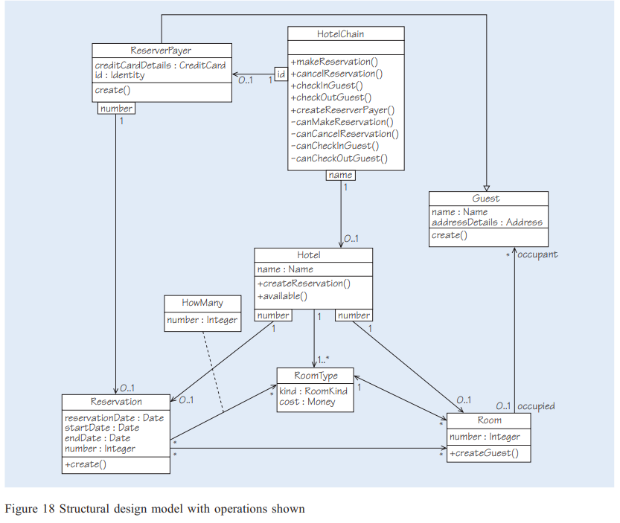
You are provided with a medium-sized UML class diagram representing a software system composed of multiple interacting domain classes.
Your task is to construct, implement, and test this system by strictly following object-oriented design principles, clean code practices, defensive programming techniques, and industry-standard testing strategies.
This project aims to assess your ability to translate a UML design into high-quality, maintainable, and testable source code.

Requirements
- Construct the Given UML Design
  - Implement all classes, attributes, methods, and relationships exactly as specified in the provided UML diagram.
  - Maintain correct access modifiers, associations, aggregations, compositions, and inheritance relationships.
- Apply Clean Code Principles
  - Ensure the code is:
    - Free from code smells
    - Properly modularized
    - Well-factored into cohesive types
  - Use:
    - Meaningful class, method, and variable names
    - Small, focused methods
    - Proper separation of responsibilities
  - Avoid duplication and unnecessary complexity.
- Apply Defensive Programming Strategies
  - Validate all user inputs and constructor parameters.
  - Handle invalid or unexpected input gracefully.
  - Use appropriate exception handling mechanisms.
  - Prevent illegal object states throughout the system lifecycle.
- Unit Testing Requirements
  - Provide test classes for each domain class.
  - All test cases must:
    - Use parameterized tests where applicable.
    - Follow strict AAA (Arrange–Act–Assert) style.
    - Test normal cases, boundary conditions, and invalid inputs.
  - Ensure tests are readable, maintainable, and behavior-focused.

GitHub Repository
Students must submit a working GitHub repository link that includes:
- Complete source code:
  - Domain classes
  - Interfaces (if any)
  - Test classes
- A README.md file containing:
  - Project overview
  - Instructions to build and run the project
  - Instructions to execute tests
- Commit History Requirements:
  - At least 5 meaningful commits
  - Commits must be made on different dates
  - Each commit should reflect logical progress (e.g., domain setup, feature addition, tests, refactoring)

The Submitted Document Must Include:
- File needs to be submitted in hardcopy
- File should not exced 4 pages
- File should be readable, remove line spacings and keep the fonts to a visible size
- Front Page should include (Program, Course, Time, Semester, Name, Rollnum)

1. GitHub Repository Link
- A clickable link to the complete GitHub repository.
- Followed by a screenshot of remote repository version history

2. Unit/Integration Test
- Include a screenshot of the test results panel confirming that all tests have passed.
- Ensure that tests cover normal cases, boundary conditions, and invalid inputs.

3. Main Program & Use Case Demonstration
Provide screenshots and brief explanations showing program execution and how it fulfills all key use cases:
- Main Method / Entry Point
  - Screenshot of the main method implementation.
  - Briefly describe its purpose (e.g., initializing hotels, rooms, and customers).
- Program Output
  - Screenshot showing:
    - Object creation (hotels, rooms, customers, bookings).
    - Interaction between objects (e.g., booking a room, checking availability).
    - Execution of all core functionality and UML use cases.
All key use cases must be demonstrated within the main method execution. Add short notes if necessary to explain which objects interact for each use case.

Evaluation Criteria
The project will be evaluated based on:
- Correctness of UML implementation
- Code quality and adherence to clean code principles
- Proper use of defensive programming techniques
- Quality, completeness, and structure of unit tests
- Correct use of parameterized tests and AAA style
- GitHub usage and commit discipline
- Clarity and completeness of documentation and screenshots

All submitted work must be original.
Any form of plagiarism, code sharing, or unauthorized collaboration is prohibited.

References
CCP-[pg193_] From Analysis to Design -Software-Engineering.pdf
CCP-Supporting.docx
CCP-Main.docx

CCP Attributes mapped
Attributes of Complex Problem Solving |  | Justification
WP1 | Range of Conflicting Requirements | In the Hotel room reservation system, the requirements for refactoring involve conflicting goals, such as maintaining backward compatibility with existing functionalities while improving code quality and performance.
WP2 | Depth of Analysis required | No unique solution exists for addressing code smells. The team needs to explore multiple refactoring methods (e.g., Extract Class, Replace Inheritance with Delegation) and select the most appropriate ones.
WP3 | Depth of Knowledge required | Analyzing the original design requires understanding of object-oriented principles, such as SOLID design, and knowledge of refactoring techniques for improving maintainability.
WP4 | Familiarity of issues | NA
WP5 | Extent of applicable codes | NA
WP6 | Extent of stakeholder involvement and level of conflicting requirements. | NA
WP7 | Consequences | Refactoring impacts future development and testing efforts, requiring careful consideration to avoid introducing new bugs.
WP8 | Interdependence | Changes in one part of the system (e.g., Room reservation logic) can affect others, requiring careful coordination and understanding of the system's architecture.

